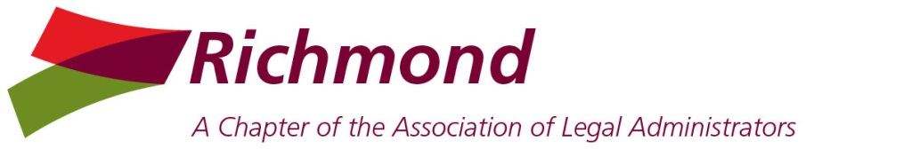 | 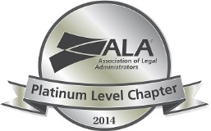

Board Meeting
Wednesday Nov 5, 2014
Noon – Hunton & Williams

PRESENT: Jen Doyle, Michael Keatts, Ellen Purcell, Nancy Pugh, Jill Shugart, Kim Brown, Ann Caudle, Cherie Heintz
Absent: Walt Arnold, Mary Ellen Cleveland, DJ Geiger

President’s Report:
- Update on 2015 Programs & Venues: looking into a CFO speaker or panel discussion. July Meeting: Any update Georgia Arnold becoming a sponsor? Nothing back from Georgia at this point.
- J. Sarge – Maryann Hartzell and Dena Wengert attended with Jill on Oct 20 from 6:15-6:55. Susan Brewer was very appreciative.
- Jill, Kimberly Atkinson, Pam Frazier, Barbara Allen-Smith and Richard Duke attended the conference in Philly. Jill met Britt Lorish at the conference.
- Have several photos to upload to the website.
- Need to get 2015 info on website; waiting on Paula Barnes and Feb program; need to teach Nancy how to do this.

President Elect Report: Nancy
- Webinars. Board decided to purchase the webinar package for 2015.
- Nov Membership Meeting: Willow Oaks Breakfast. Jill taking responsibility for venue and speaker (Wendy Inge.)
- Dec Membership Meeting: Valentine Room. Jill will follow up with Sherri.
- Reminder: Dec 9 is the Board Meeting at private room at Travinia.

Vice President - Membership: Mary Ellen (Absent)
- Ellen recommended Abby Davis Hess and will forward info to Mary Ellen
- Shari Adams & Carol Maddox. Joined ALA. Both have joined Richmond.
- Evan Smith & Marjorie Isom. Joined Richmond but not ALA. Mary Ellen will follow up. Technically these folks are not members until they have paid with ALA.
- Received a $25 gift card from Chez Foushee.
- Working on new Richmond application in pdf format; will add bio and photo for website & member directory from the get-go. Ellen offered to ask her IT group for help with this.
- Membership Renewals will go out in early November. Need to confirm payment due date (Jan 15, 2015?) and highlight sliding scale for multiple members of the same firm. Can send via StarChapter.

Treasurer’s Report – Ellen
- Budget thru rest of year; reconciled balances:
SunTrust - $7,555.79 and C&F - $9488.98
- Discussed cost of credit card transactions with SunTrust. We will try to get together with Wendy Inge to see if she can help.
- Discussed whether BP Liaison should have a debit card. Discussed whether we should have debit or credit card to simplify the record keeping.
- Report: Attached
- Ellen and Jill to look into using Money Manager for tracking Chapter finances.

Business Partner Liaison – Michael/Maryann
- Silver Sponsors Social - Spirited Art - Tues Nov 18.
- Prospective BP Breakfast. 9 prospective BP’s attended breakfast, 3 have signed up.
- 2015 BP Sponsorship renewals to-date, Board reviewed spreadsheet

Secretary’s Report – Kim
- Board approved Board Meeting Minutes for September & October
- Board approved Membership Meeting Minutes for September & October

Communications Officer - Jennifer
- Status Update on Award of Excellence Progress & Remaining “To-Dos”. Jennifer will collect testimonials and update website link.
- While at Philly conference, Jill gave George Leloudis a copy of our tracking for feedback.

Community Connections - Cherie
- Cherie to send a thank you note to Walt.

Corporate Legal Administrators Committee –
- Congratulations to Walt on his new position with Altria. Need replacement for Walt; Walt is helping us with this transition. Ann will call Kym Johnson to see if she is interested.

CLM Committee – DJ
- CLM Exam Fee Reimbursement Policy: Board voted to have a one-time reimbursement of $500 for passing the exam.

Immediate Past President/Bar Liaison Chair – Ann
- MWBA: Ann scheduled a luncheon meeting with Yvonne McGehee on Oct 20 with Jill & Cherie.
- Twitter Brown Bag Lunch ‘n Learn: Nov 13 @ Spotts Fain; Ann will host and train on the basics. Invited BPs at Flemings.
- Nominating Committee discussion: Kimberly Atkinson and Sarah Paris.

Attachments:
CLM Exam Fee Reimbursement Policy
Treasurer’s Report

