
August 2022 Member Meeting Minutes
August 25, 2022
12:00pm to 1:30pm
Fleming’s Steakhouse

Meeting was called to order by Christina Bloom President at 12:00pm.
Introduce and Thank Business Partners:

Platinum Business Partner
Gold Business Partner
Silver Business Partner
Bronze Business Partner
Atlantic Union Bank (John Lester)
Konica Minolta (Tyler Zameroski)
Actionstep (Joe Loving)*

*Meeting Sponsors
New Members Present:
Danielle Dann Herbert & Satterwhite, PC
Katelyn Vise MeyerGoergen, PC

Announcements
Sept 16 | Business Partner Appreciation Social – The Diamond
Oct 27 | Cybersecurity Panel Discussion – Willow Oaks Country Club
Nov 17 | I know I need it, but where do I start? Navigating your Practice Management Options, Presenter Beth Thompson, Affinity Consulting at the Boathouse at Rocketts Landing

Meeting/Speaker Introduction:
Presentation: Estate Planning and Asset Protection Planning
Presenters:
Eldridge Blanton is a Principal at Carrell Blanton Ferris. He focuses his practice in the areas of estate planning, retirement planning, elder law, and wealth preservation … and particularly, helping his clients prepare comprehensive estate and retirement plans. His education includes degrees from VMI, the University of Richmond, and the College of William and Mary.
David Thornton joined the firm in 2020 and practices in estate planning. As the father of two young girls, David understands firsthand the reassurance that a sound comprehensive estate plan brings to a family. David received his B.A. from Christopher Newport University and his J.D. from George Mason University.
Meeting Attendance:
Total No. Members Attending | 24
Total No. Guests w/Member | 0
Total No. Guests w/BP | 0
Other Guests
Speaker(s) | 2
Business Partners | 3
TOTAL | 29
Meeting was adjourned at 1:30pm.

Respectfully Submitted,
Billie Jo Brooks
Richmond Board Secretary

Survey Results
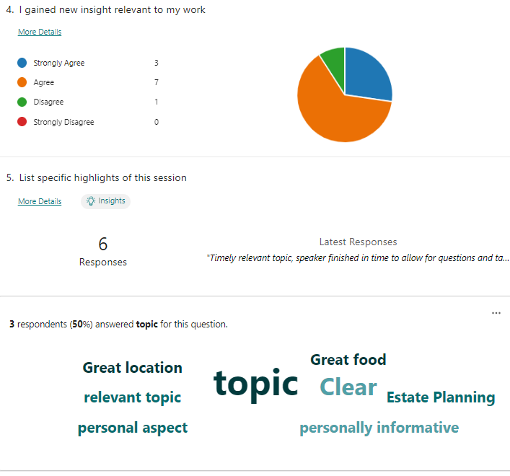
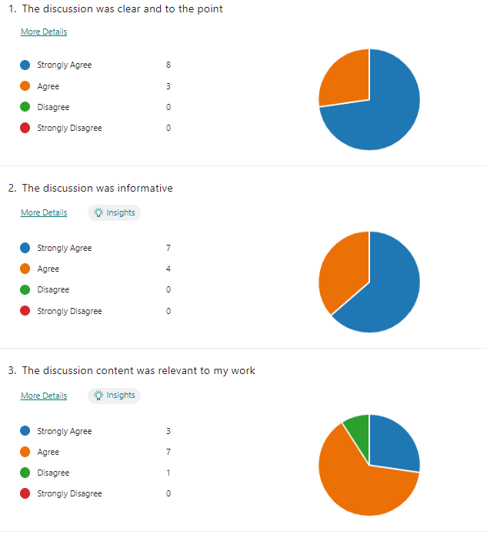

5. List specific highlights of this session
6 responses6Responses
ID | Name | Responses
1 | anonymous | Clear and insightful presentation.
2 | anonymous | personally informative
3 | anonymous | I like how this topic rolled into the personal aspect of personal management.
4 | anonymous | Clear and interesting take on a mostly boring but necessary topic.. Great location! Great food
5 | anonymous | The different areas within Estate Planning and Administration to consider.
6 | anonymous | Timely relevant topic, speaker finished in time to allow for questions and table discussion

6. What topics/issues/instructors would you recommend for future presentations?
3 responses3Responses
ID | Name | Responses
1 | anonymous | Round Table on how to recruit and retain good employees in this market
2 | anonymous | I would like to try and have Trevor Reid of Parker Pollard speak as to the starting of business. Let me know if interest.
3 | anonymous | How to recruit and retain good employees in a post-pandemic environment

