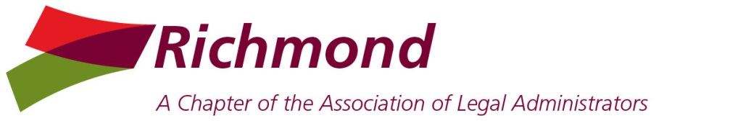 | 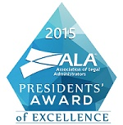

Board Meeting
Wednesday Jul 8, 2015
Noon – Hirschler Fleischer

PRESENT: Jill Shugart, Nancy Pugh, Ellen Purcell, Michael Keatts, Kim Brown
Absent: Cherie Heintz, Ann Caudle, Mary Ellen Cleveland

President’s Report:
- Award of Excellence – THANK YOU! 56% of chapters received this designation. Logos are in StarChapter under Chapter Documents
- ALA Membership Demographics; ALA 2015 total membership down 753; Region 2 down 135; Richmond at par thru 2nd Q; Membership Reconciliation completed and sent to national ALA
- Replacement for Jen Doyle as Communications Chair - Jill will reach out to Anne Henkel
- Nancy Pugh will be stepping up at Jill Shugart’s resignation.
- Scholarship to CLAC member - Board approved to pay for early bird registration, Jill will contact Many and Melissa
- ALA Training Session Webinar from Affinity won by Michael at the national conference. The Board has selected a lunch webinar for October 8th - Eight things killing your law firm.
- Future Dates:
  - July 23-25 – Chapter Leadership Institute – Grand Rapids, MI (Nancy & Cherie will be attending)
  - Oct 1-3 - Business of Law Conference East – Atlanta, GA
  - Oct 22-24 – Business of Law Conference West – Las Vegas, NV
- Next Board Meetings:
  - Aug 6 – H&W; Nancy & Jill have met to review the calendar and discuss speaker and venue ideas; survey out soon for potential speakers and topics from general membership.
  - September 9
  - November 4
  - December 2 (gift exchange)

President Elect Report: Nancy
- May Membership meeting survey results: 3.4
- Jun Membership meeting survey results: 3.6
- Jul Meeting attendance numbers: 21
- Webinars update - One or two members continue to participate.
- Sept Meeting – CLE - 4:00p SunTrust
- Nov Meeting Date Change to Thurs Nov 19; venue is Willow Oaks for breakfast

Vice President - Membership: Mary Ellen
- Membership Renewals Status: 59 on ALA rolls; 60 with AnnMarie Penman
- Recruitment Drive – Add One More for $44 - Jill will announce
- Need to recruit Lara Pasternack Small (Renee Wlodkoski’s replacement at Goodman Allen)
- Need Jen Doyle’s home e-mail address for StarChapter
- Greg Negus has left McGuire Woods to take a similar job at Ogletree in NC

Treasurer’s Report – Ellen
- 2015 Budget and Reconciled Balances. ST: $25,381.70 C&F: $9,488.98
- Nancy will forward receipt for June meeting payment.
- Discussed cost of credit card transactions with SunTrust.
- Debit card for BP Liaison completed.
- Tax Return status. Jenny Belcher requested gross receipts for 2010-2013. Return due August 15th.

Business Partner Liaison – Michael/Maryann
- BP Silver Social – June 3
- Seltek Social - October (Wendy Logan is working with Maryann)
- Prime Legal Social - August
- Cobb Social Thurs July 16 – Squirrel’s Game
- Small Fee Sponsorships: Lexis, Michelle, Proxios, etc. (Apple One, Dictation Store, Richmond Express)
- BP E-Blast
- BP Appreciation Luncheon in October – Chocolates will be ordered and drawing for a Fitbit.
- Prospective BP Breakfast – October 7th followed by Board meeting.

Secretary’s Report – Kim
- Board voted on and approved Board Meeting Minutes and Membership Meeting Minutes for May and June.
- All meeting minutes for 2015 have been sent to National and posted on the Chapter website.

Communications Officer –
- Award of Excellence – Updated spreadsheet attached.

Community Connections & Caring - Cherie
- Christmas in June results - Cherie will update at next Board meeting.
- Stacey Brinkley from the Doorways to talk to the membership - to be discussed at next Board meeting.

Corporate Legal Administrators Committee – Ann
- August meeting update - Nancy will run if Jill is on vacation. Kym Johnson will serve as the moderator of the meeting.

Immediate Past President/Bar Liaison Chair – Ann

Attachments:
Treasurer’s Report

