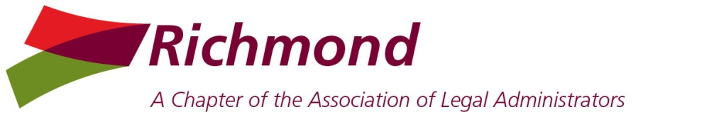

Board Meeting Minutes
Thursday, May 13, 2021

Attendance – Kim Brown, Dave Cummings, Anne Henkel, Michael Keatts, Nancy Pugh, Christine Purgason, DeAnna Vanover
(Absent: Christina Bloom, Cherie Heintz)

Call to Order – President Kim called the virtual meeting to order at appx 12:00 PM.

President’s Comments
Welcome – Kim welcomed Christine to the board
Chapter Leadership Institute – Kim noted that in-person sessions would be held in St Louis, Missouri, on July 16-17; the chapter would pay for two board members to attend; DeAnna and Christine will check their schedules
National Conference – Kim noted that the 2021 conference and expo was scheduled for October 3-6 in Austin, Texas; Kim confirmed that two registrations carried over from 2020, and would schedule a drawing for an additional scholarship

Secretary’s Report
Minutes – Upon motion duly made and seconded, the minutes for the April BOD and member meetings were approved
Transition – Dave reported that he had connected with Christine to transition the secretary responsibilities

Treasurer’s Report
Tax return – DeAnna noted that Christina had coordinated the 2020 tax work with Keiter
Annual report – DeAnna agreed to finalize the annual chapter report and submit it to the SCC

2021 Programming and Events Review
May – Kim confirmed that ABA Retirement would sponsor a joint meeting on “The Power of Style” with LMA and several other ALA chapters on May 20; Linda Cooper will send out give-away items to attendees
June – Anne and Christine agreed to coordinate an afternoon virtual roundtable discussion with Proxios on “back to the workplace” topics
July – Kim agreed to coordinate a July meeting on a topic to be determined
August/September – Kim noted that in-person meetings could likely begin in September
Events – Kim scheduled the December holiday meeting with the Jefferson Hotel

Business Partner Liaison Report
Participation – Anne noted that 12 BPs were expected to participate in the May member meeting
Events – Anne agreed to plan a BP recognition event for the fall

Membership Report
Member update – Kim confirmed dues payment status of several new members with National
Directory – Kim will review the member information form with Christina to gather info for the new directory

Community Connections Report
Events – Nancy agreed to consider options for volunteer events

Virginia Statewide Retreat Report
Survey – Michael indicated that BPs would be contacted to gauge interest in sponsoring a March 2022 event

Adjournment – With no further business to address, President Kim adjourned the meeting at 12:40 pm. Next meeting on June 8.

Respectfully submitted by:
Dave Cummings, Secretary

