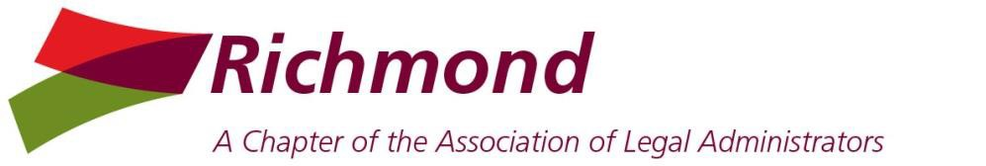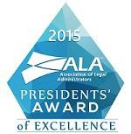

Board Meeting
Wednesday, January 6, 2016 Noon
Allen, Allen, Allen & Allen
PRESENT: Nancy Pugh, Mary Ellen Cleveland, Ann Caudle, Kristi Mullins, Kim Brown, Michael Keatts, Ellen Purcell, Cherie Heintz
ABSENT: Anne Henkel

President’s Report: Nancy
- Planning for 2016 – Michael, Kristi and Ann will enter meeting on the Chapter’s website. Kristi will test member access.
- Webinars – 2016 – The Board discussed purchasing 5 webinars.
- Board Meeting - Nov 6 – should be 11/2, Michael agreed to update.

President Elect Report: Kristi
• Kristi will choose 4-5 webinar topics of interest and circulate them to the Board for review.

Vice President - Membership: Mary Ellen
- New Member Luncheon will be scheduled for a date in April. All new members from 2015 and 2016 will be invited.
- Projected Chapter membership for 2016 is 57-60 members.

Treasurer’s Report – Ellen
- 2015 Budget and Reconciled Balances.
- 2016 Budget - Nancy, Ellen Cherie and Ann will schedule a time to meet at HF to discuss the budget for 2016.

Business Partner Liaison – Michael/Maryann
  - Status of sponsorships and payments to date - see attached spreadsheet.
  - Statewide Retreat 2016 Update.

Secretary’s Report – Kim
- The Board voted approved Board and Meeting minutes for December 2015.

Communications Officer – Anne - No report

Community Connections & Caring - Cherie
- Events will be scheduled once meetings are finalized.
Corporate Legal Administrators Committee – Ann - No report

Immediate Past President/Bar Liaison Chair – Ann
- The nominating will be formed to prepare for 2016 Elections in March.

Attachments: Treasurer’s Report

